# MongoDB -Aggregation Exercises

Import the zips.json file into your MongoDB. Database name is "population" and collection name is "zipcodes".

mongoimport --db population --collection zipcodes --file zips.json

# Atlanta Population

1. **use db.zipcodes.find() to filter results to only the results where city is ATLANTA and state is GA.**

db.zipcodes.find({$and:[{"city":"ATLANTA"},{"state":"GA"}]})

1. **use db.zipcodes.aggregate with $match to do the same as above.**

db.zipcodes.aggregate({$match:{"city":"ATLANTA","state":"GA"}})

1. **use $group to count the number of zip codes in Atlanta.**

db.zipcodes.aggregate([{$group:{_id:{city:"ATLANTA"},zipcodescount:{$sum:1}}}])

1. **use $group to find the total population in Atlanta.**

db.zipcodes.aggregate([{$group:{_id:{state:"$state"},totalpopstatewise:{$sum:"$pop"}}}])

# Populations By State

1. **use aggregate to calculate the total population for each state**

db.zipcodes.aggregate([{$group:{_id:{state:"$state"},totalpopstatewise:{$sum:"$pop"}}}])

1. **sort the results by population, highest first**

db.zipcodes.aggregate([{$group:{_id:{state:"$state"},totalpopstatewise:{$sum:"$pop"}}},{$sort:{totalpopstatewise:-1}}])

1. **limit the results to just the first 3 results. What are the top 3 states in population?**

db.zipcodes.aggregate([{$group:{_id:{state:"$state"},totalpopstatewise:{$sum:"$pop"}}},{$sort:{totalpopstatewise:-1}},{$limit:3}])

# Populations by City

1. **use aggregate to calculate the total population for each city (you have to use city/state combination). You can use a combination for the _id of the $group: { city: '$city', state: '$state' }**

db.zipcodes.aggregate([{$group:{_id:{state:"$state",city:"$city"},totaltotalpopstatewise:{$sum:"$pop"}}}])

1. **sort the results by population, highest first**

**limit the results to just the first 3 results. What are the top 3 cities in population?**

population>db.zipcodes.aggregate([{$group:{_id:{state:"$state",city:"$city"},totaltotalpopstatewise:{$sum:"$pop"}}},{$sort:{totalpopstatewise:-1}}])

1. **What are the top 3 cities in population in Texas?**

db.zipcodes.aggregate([{$group:

{_id:{state:"TX",city:"$city"},

totalpopstatewise:{$sum:"$pop"}}

},{$sort:{totalpopstatewise:-1}},{$limit:3}])

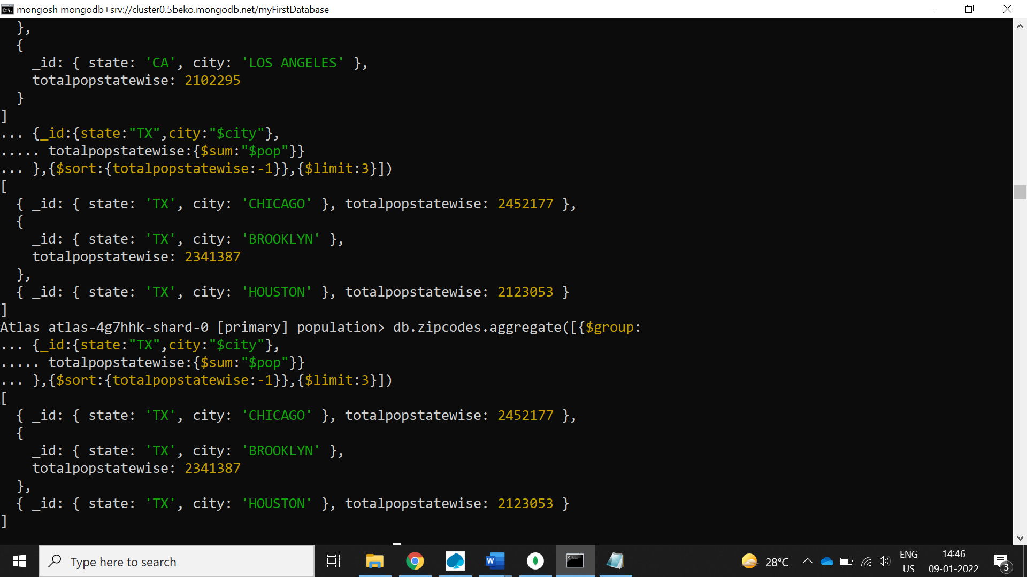

# Bonus

1. **Write a query to get the average city population for each state.**

db.zipcodes.aggregate([{ $group: { _id: { state: "$state" }, avgpopstatewise: { $avg: "$pop" } } }, { $sort: { avgpopstatewise: -1 } }])

1. **What are the top 3 states in terms of average city population?**

db.zipcodes.aggregate([{ $group: { _id: { state: "$state" }, avgpopstatewise: { $avg: "$pop" } } }, { $sort: { avgpopstatewise: -1 } }, { $limit: 3 }])